## The Heating Model

The Heating Model is a heat loss model which has several functions, as presented in Figure 3:

1. Calculating existing demand for space heating and domestic hot water and adjusting it to statistics and/or local conditions.
2. Calculating potentials and costs of heat saving measures.
3. Approximating potentials and costs of heat saving measures and feeding them into one of energy system models.
4. Making projections of future heating demand based on the assumptions regarding renovation, construction and demolition rates.
5. Visualizing and geographically representing results in GIS-based tools such as DTU Energy Atlas.

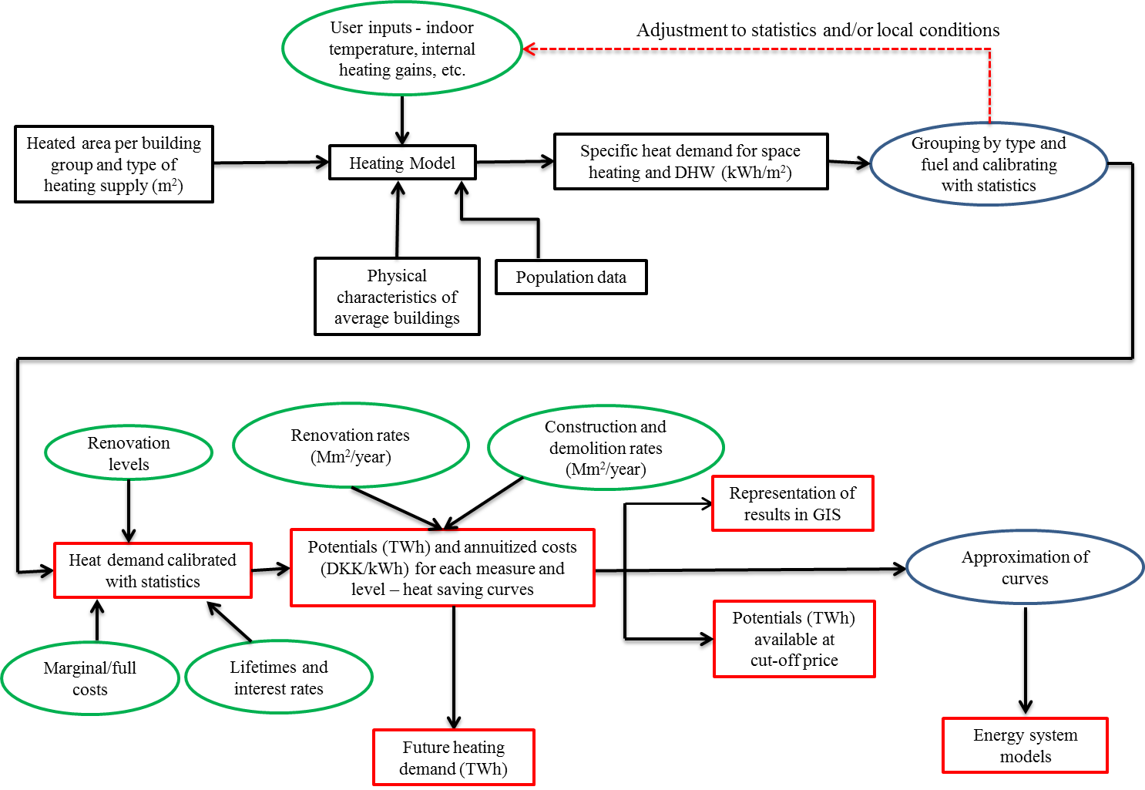

Figure 3 Inputs, outputs and flows in Heating Model

The user inputs are put into the green shapes, results into the red, data inputs into the black and data manipulation procedures in the blue ones. The workflow of the model is as follows:

* The total heated areas, physical characteristics (weighted average u-values and f-values, ventilation and infiltration rates, etc. originating from [2, 3, 4]), population data [1], and user inputs are inputted for each building group.
* Specific demand for space heating and domestic hot water (kWh/m2) is calculated for each building group, aggregated and compared with statistics. If the match with the statistics is initially not achieved, user inputs are changed until the satisfactory match with the statistics is achieved.
* Several renovation levels are assumed for the components of buildings' envelopes – floors, walls, roofs, windows and ventilation systems, as presented in Table 1. The heat saving potential for each renovation level is calculated as a difference between current heating demand and heating demand after the assumed renovation. The marginal and full costs of heat saving measures are collected from SBi's reports [2, 3, 4]. The marginal costs represent costs of heat saving measures if they are done after the end of the lifetime of a specific component. The full costs represent costs of heat savings if they are done with the sole purpose of saving heat. The costs are annuitized with 4 % discount rate over the lifetimes of different components of building envelope (20 years for ventilation systems, 25 years for windows, 35 years for roofs and 40 years for floors and walls).
* For each component of buildings' envelopes, the most cost-effective heat saving measure (i.e. the lowest amount of DKK[1] per saved kWh) is chosen. These costs (in DKK/kWh) and associated potentials (in kWh) are aggregated, ordered from the least to the most expansive and thus heat saving curves are obtained.
* On one hand these results can be visualized in a GIS-based tool such as DTU Energy Atlas. On the other hand, these curves can be approximated and used as inputs to energy system models, as presented in [5].
* If the construction, demolition and renovation rates are assumed, the Heating Model provides projections of the future heating demand.

Table 1 Assumed heat saving measures for component of building envelope

|  |  |
| --- | --- |
| Component of building envelope | Heat saving measure |
| Wall | Adding insulation – 100 mm |
| Adding insulation – 200 mm |
| Adding insulation – 300 mm |
| Roof | Adding insulation – 100 mm |
| Adding insulation – 200 mm |
| Adding insulation – 300 mm |
| Floor | Adding insulation – 50 mm |
| Adding insulation – 100 mm |
| Adding insulation – 150 mm |
| Window | Installing A+ windows |
| Installing A windows |
| Installing B windows |
| Installing C windows |
| Ventilation | Installing ventilation systems with heat recovery |

# References

1. Statistics Denmark. Population count on 1. January divided on sex, location and year. <[www.statistikbanken.dk/BY1](http://www.statistikbanken.dk/BY1)>; 2015 [accessed 01.10.15.].
2. Wittchen, K. B., SBi 2010:56 Danske bygningers energibehov i 2050.

<<http://www.sbi.dk/miljo-og-energi/energibesparelser/danske-bygningers-energibehov-i-2050/danske-bygningers-energibehov-i-2050>>; 2010 [accessed 01.10.15] [in Danish].

1. Wittchen, K. B., Kragh, J., & Aggerholm, S. Potential heat savings with continuous building renovation until 2050, Danish Building Research Institute (SBI). Available at: <<http://www.sbi.dk/miljo-og-energi/energibesparelser/potentielle-varmebesparelser-ved-lobende-bygningsrenovering-frem-til-2050>
2. Wittchen, K.B., Potential energy savings in existing buildings. Danish Building Research Institute. <<http://www.sbi.dk/miljo-og-energi/energibesparelser/potentielle-energibesparelser-i-det-eksisterende-byggeri/potentielle-energibesparelser-i-det-eksisterende-byggeri>>; 2009 [accessed 01.10.15] [in Danish]
3. Petrović, S.N. and Karlsson, K. B., Danish heat atlas as a support tool for energy system models, Energy Conversion and Management, Vol. 87, No. 15, pp 1063–1076, 2014.

1. DKK denotes Danish Crown throughout the paper. 1 DKK=0.134 EUR